Activity Title: | 01-01.Plan for Chemistry 1 - Semester 1 |  |  | v09
Learning Target: |  | To identify the topics covered in Chemistry 1 - Semester 1
Authors/References: |  |  | Victor Sojo/DepEd-SHS General Chemistry 1 and 2
Topic | Material
1. Introduction to Chemistry | The substances we touch, see and eat, are made of matter. Chemistry studies substances and how and why they transform into different substances (react).
2. Matter and particles | - Matter is made of atoms, which are made of smaller particles called protons, neutrons, and electrons.  - Identical atoms are atoms of the same element.  - Elements can combine to form compounds. For example, water is a compound. It is made of atoms of two different elements: hydrogen and oxygen.
3. Electrons, orbitals and the Periodic Table | - Quantum Theory describes how electrons distribute in orbitals around the nucleus made of protons and neutrons.  - Elements can be ordered according to their properties.
4. Bonds | - Atoms can bond (attach) to each other in many ways.  - The ways in which atoms are bonded to each other in salt, sugar and iron are very different.
5. Naming chemical compounds | Because there are so many chemical compounds, chemists have created systematic (organized) ways of naming them. This is called chemical nomenclature.
6. Reactions and Stoichiometry | - The processes by which substances change into different substances are called chemical reactions.  - Reactions often (but not always) involve changes in color, temperature, or appearance (looks).  - It is possible to express these reactions as mathematical relations (formulae), called chemical equations.  - These equations let us calculate the amounts of the substances that react (the reagents) and predict the amounts of the substances formed (the products).  - Reactions can happen in gases (such as air), in liquids (like water) and sometimes even in solids (like metals).
7. Aqueous solutions | - Water is a very special molecule, with a negative end and two positive ends. This makes it a polar solvent (it has “poles”, like a magnet or a planet).  - Water dissolves many substances, such as salt and sugar, but not many others, like oil or gold.

Questions
- Give an example in which you think a chemical reaction has happened; for example, when an iron screw turns orange (rusts or “oxidizes”) over time.
- We saw the elements hydrogen and oxygen above. Can you name any others?
Activity Title: | 01-02.Matter and substances |  |  | v06
Learning Target: |  | To demonstrate that the substances around us are made of matter, which has a mass and occupies a volume
Authors/References: |  |  | Victor Sojo

Substances like the water we drink, the air we breathe and the chairs on which we sit are made of matter.
Matter has a mass (m) and occupies a space or volume (V).

Laboratory experience
- Weigh an empty glass or container to determine its mass in grams [g].
- Fill a jug with water and then weigh it too.
- Pour water into the glass and weigh the glass again. Weigh the jug also.
- Draw a line on the glass with a marker, to indicate the level of the water.
- Find a rock or a large marble and weigh it, then drop it into the glass.

- Weigh the glass again. Also, have a look at the volume: did it change?
Object | m [g] |  |  | m_{mean} [g]
Jug with water
Glass (empty)
Glass with water
Jug after pouring water
Rock
Glass with water and rock/marble
Note: always measure in triplicates (weigh three times, then get the mean)

Questions
- Did the total mass (glass+contents) change at steps 3 and 6? How much?
- Can you calculate the mass of the water that you added?
- Was the “empty” glass really empty? Why?
Activity Title: | 01-03.Physical and chemical changes |  |  | v03
Learning Target: |  | To differentiate between physical and chemical changes
Authors/References: |  |  | Victor Sojo

Chemistry studies how matter (substances) changes into different matter (other substances). These processes of chemical change are named chemical reactions.

Some examples of chemical changes or chemical reactions are the rusting of an iron nail over time, or the cooking of an egg. We can often detect that a reaction has happened because colors, smells, textures or tastes change. 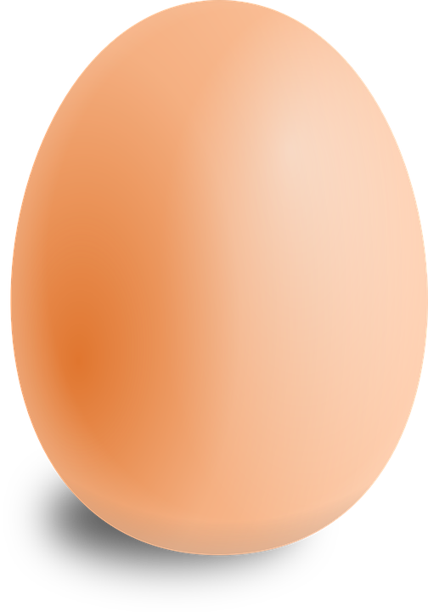
But often, even very obvious changes do not necessarily involve a transformation of substances into other substances. For example, liquid water can be frozen into ice, or it can be boiled into vapor, but it is still water. We know this because when ice melts or vapor condensates, we get liquid water again. These changes are known as physical changes.

Questions
- Do you think that all chemical changes involve a change in color, smell, taste, or texture, or do you instead think that maybe there are some chemical changes that are difficult to detect with our body’s senses?
- When wood burns, it turns into gases that go into the atmosphere. Some of these gases can then be re-absorbed by plants and turned back into wood. Do you think these changes are chemical or physical? Why?
Activity Title: | 01-04.Chemistry, the “Central Science” |  |  | v03
Learning Target: |  | To discover why chemistry is called the “Central Science”
Authors/References: |  |  | Victor Sojo

Chemistry is often called the “Central Science” because it stands between Physics (the study of matter and energy) and Biology (the study of living organisms, which are so full of energized chemical compounds and reactions).

As the figure depicts, Chemistry is also very important for most other sciences and even many of the arts!

Questions
- Choose any three of the disciplines above, or any other that we didn’t include, and discuss how you think Chemistry is related to them. For example, we didn’t mention Meteorology, the study of the atmosphere. Chemistry is related to it because, in order to understand the weather, meteorologists need to study how the many chemical compounds in the atmosphere behave.
- If Chemistry is the central science, does it mean it’s more important than Physics, Biology, and the other sciences?

Activity Title: | 02-01.Dividing sugar in half infinitely |  |  | v05
Learning Target: |  | To discuss whether substances can be divided endlessly
Authors/References: |  |  | Victor Sojo

Laboratory experience
- Pour a teaspoonful of sugar onto a flat surface.
- Divide roughly in half and give the other half to a fellow student.
- Take your half and divide it roughly in two again. Keep one part and push the other part away to create a waste pile.
- Divide the portion you kept in two once more and put the unwanted sugar into the discard pile. The portion we kept is a half of the half of the initial half of the full spoonful.
- Quickly keep doing this again and again and again until only one little crystal of sugar is left.
- It seems we’ve reached the end. Maybe not: try to squash this last crystal with a spoon or spatula. Can you start the division process again?
- There will be a point at which you can’t divide the sugar in half anymore.

Analysis
We reached the end of the experiment, but maybe we could have kept going if we had a very sharp knife and a magnifying glass, or even a microscope. Perhaps with the sharpest knife and the best microscope in the world we could carry on dividing the sugar forever… Could we?
The answer is not obvious, but it is “no, we cannot”, or at least not without destroying the identity of the sugar. Even if we had such a knife, there would be a point at which we would reach the most basic block of the sugar, in this case, the molecule of sucrose. If we break it further, which is certainly possible, we would have the atoms that compose it (carbon, hydrogen, and oxygen), but no longer sugar.
Note: Make sure to clean up the surface and get rid of all the sugar.
Activity Title: | 02-02.Substances are made of atoms, which are very small |  |  | v03
Learning Target: |  | To familiarize with how small and how many atoms are
Authors/References: |  |  | Victor Sojo

All chemical substances, such as water, gold, air, salt and sugar, are made of atoms.

Atoms are extremely small, much smaller than we can normally imagine. In just one teaspoon of common table salt (sodium chloride), which weighs about 5 g (“five grams”), there are approximately:
5,152,413,464,900,000,000,000
sodium atoms! And that’s only half: there’s the same number of chlorine atoms!

Combined, that’s over ten sextillion atoms! Almost nothing we see in our daily life comes in such huge numbers. All the money in the world, even all the hair of all people and animals combined, all the leaves of all trees, all the rocks… none of them come anywhere near those numbers.

And this is only in a teaspoon… imagine how many atoms of sodium there are in all the salty water of the sea!

Questions
- Let’s leave the calculation of the number of sodium atoms in the sea for later. For now, let’s tackle a simpler problem: how many atoms of sodium are there in a 1 kg packet of table salt?
- There is actually at least one visible thing that might come relatively close to the gigantic number above. Hint: it is very very small but you can still see it, and it can also be found near the sea or at the bottom of it.
Activity Title: | 02-03.Atoms are made of “subatomic” particles |  |  | v04
Learning Target: |  | To illustrate how atoms are made of subatomic particles called protons, electrons and neutrons
Authors/References: |  |  | Victor Sojo / OED:atom; Brown: The Central Science
The word “atom” comes from the Greek word “átomos” which means “indivisible”. The reason for this name is that ancient philosophers in Greece, and before them in India, used to think that matter was composed of very small particles that could not be divided.
They were right about the small particles, but they were wrong about their being indivisible. In fact, through the careful work of many generations of scientists, we now know that atoms are made of three main subatomic particles: protons, neutrons, and electrons.
Let’s look at a very simplistic model of the atom:
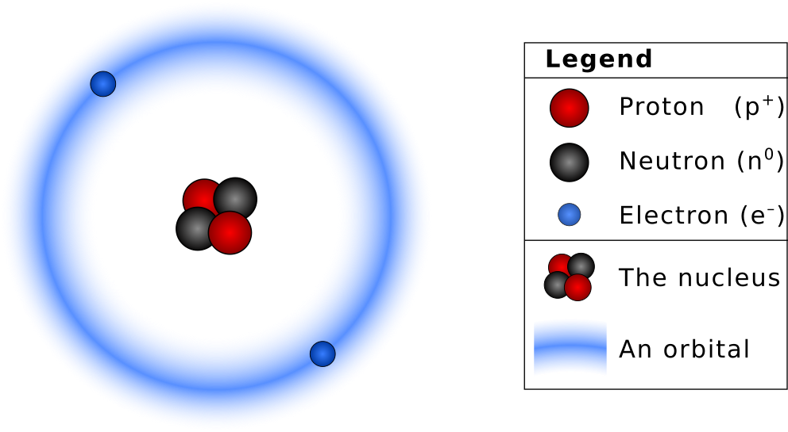
Protons and neutrons are clustered together in the nucleus. Electrons are distributed far away in orbitals, in ways that we will study later.
Protons have a positive electric charge, electrons are negative, and neutrons don’t have any charge (which is why they have that name).
In a neutral atom, the number of electrons and protons is the same.
Question - Review from Grade 9-10: What is the main difference between Thomson's "plum pudding" and Rutherford's "planetary" models? Make drawings to discuss the difference.
Activity Title: | 02-04.Identical atoms are atoms of the same element |  |  | v03
Learning Target: |  | To explain that there are 118 chemical elements, each with its own type of atom
Authors/References: |  |  | Victor Sojo

Atoms are made of protons and neutrons in the nucleus, and electrons distributed in orbitals around the nucleus.
If two atoms are identical, they are atoms of the same chemical element.
There are 118 known elements. Some have names you may recognize, like carbon, gold, silver, oxygen, hydrogen, or sodium; but there are many with less famous names, such as thulium, seaborgium or praseodymium.
If we compare two atoms, their number of protons could be the same or it could be different, and the same applies to neutrons and electrons.
We can consider what would happen if we vary the number of each of the three subatomic particles. We will do this in detail in later LASs, but just as an introduction:
- Protons determine the element: atoms with a different number of protons in the nucleus are atoms of different elements. Carbon always has 6 protons, uranium always has 92, and hydrogen only 1.
- Electrons determine the ion: since protons are positive and electrons negative, if we vary the number of electrons the atom will have a charge and we instead call it an “ion” (pronounced “eye-on”).
- Neutrons determine the isotope: two atoms can be different just in their number of neutrons. These are called “isotopes” of the element. Carbon, for example, has three natural isotopes; nitrogen has two.

Question
How many electrons do the (neutral) atoms hydrogen, carbon, and uranium have? Does this mean they always have an equal number of protons and electrons?
Activity Title: | 02-05.Protons in the nucleus determine the element |  |  | v04
Learning Target: |  | To explain that the number of protons in the nucleus is always the same for the same element.
Authors/References: |  |  | Victor Sojo

Chemists write elements with a one- or two-letter symbol. For hydrogen, this is just H.
Sometimes chemists also write a little number on the bottom-left corner of the symbol. This is the number of protons in the nucleus, Z, so hydrogen would be ₁H, because hydrogen atoms have only 1 proton.
The number of protons Z is always the same for each element.
The second element is helium, with 2 protons, and then come lithium with 3, beryllium has 4, boron 5 and carbon 6. Let's make model drawings of these six atoms, including the orbitals but leaving out the electrons:
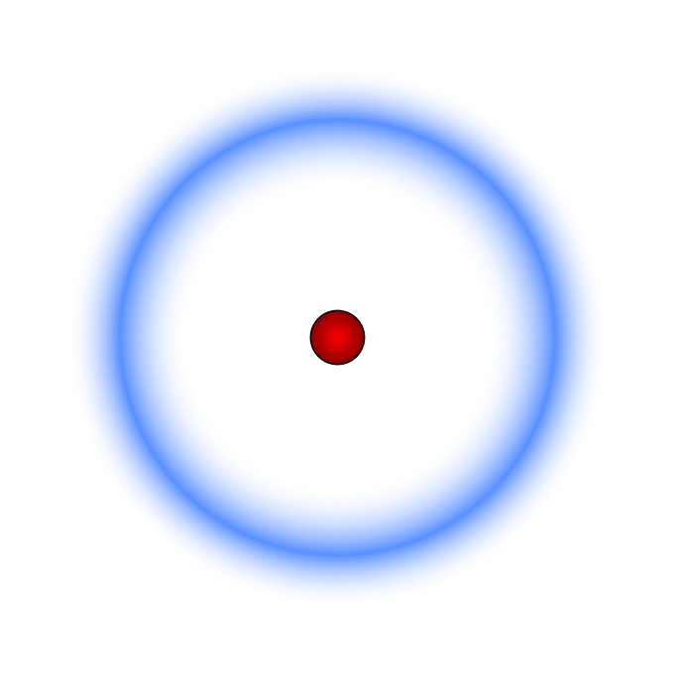 | 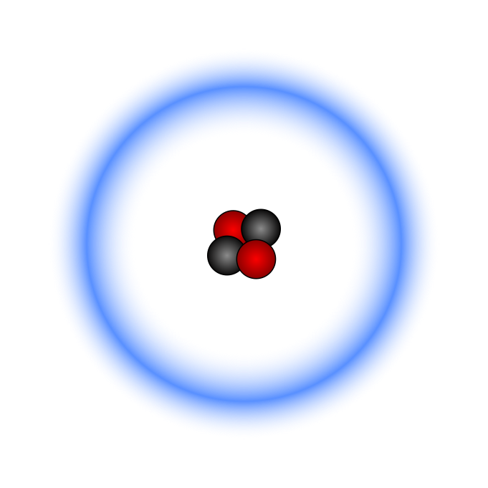 | 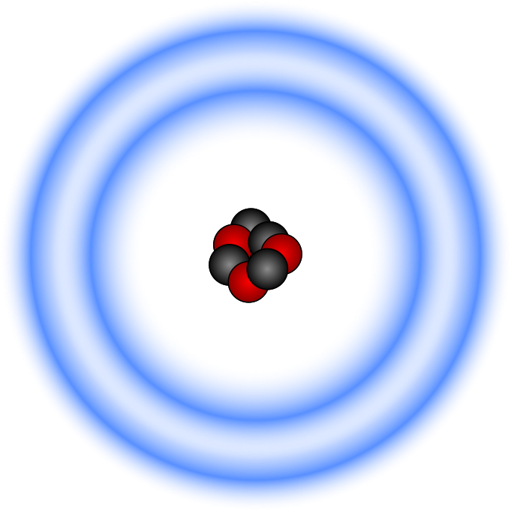
₁H: Hydrogen | ₂He: Helium | ₃Li: Lithium
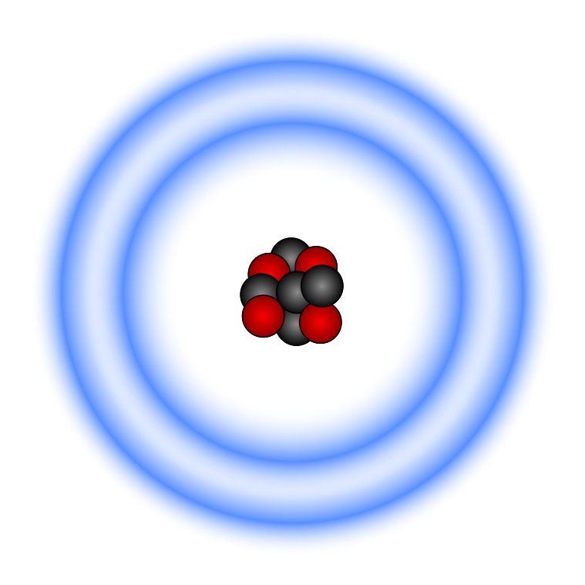 | 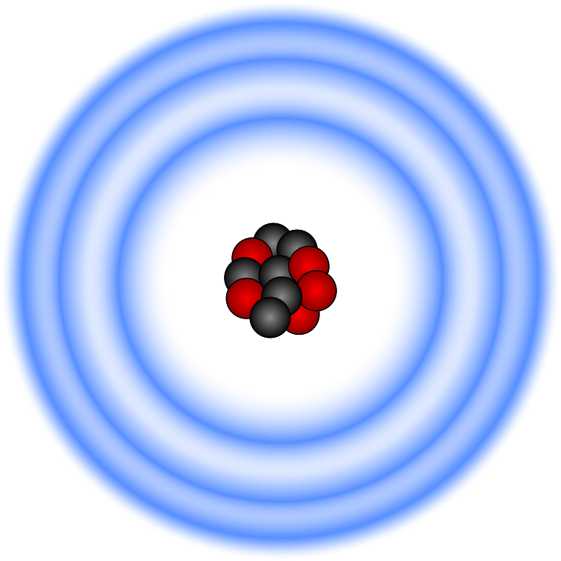 | 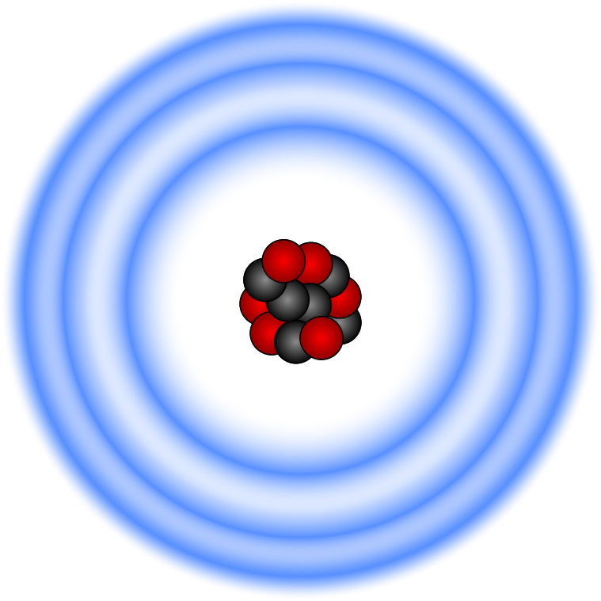
₄Be: Beryllium | ₅B: Boron | ₆C: Carbon

Question
Look at a periodic table of the elements. Can you notice any pattern in the order of the elements when you compare it to the list above?
Activity Title: | 02-06.Electrons determine the charge of the atom or ion |  |  | v03
Learning Target: |  | To calculate the charge of atoms and ions
Authors/References: |  |  | Victor Sojo

We saw how a different number of protons makes the atom into a different element. But actually, the number of protons does not normally change in chemical reactions. Conversely, the number of electrons does change rather often, and many chemical reactions involve changes in the numbers of electrons.
Since protons (p⁺) are positive and electrons (e–) are negative, if their numbers are not the same the atom will have a charge. When this happens, we don’t normally call it an atom anymore, but an “ion” instead.
Electrons are negative, so when a neutral atom gains one it becomes a negatively charged ion, also called an “anion” (pronounced an-eye-on). Losing electrons produces a positively charged ion, or “cation”.
Charge is written in the top-right corner of the element’s symbol.
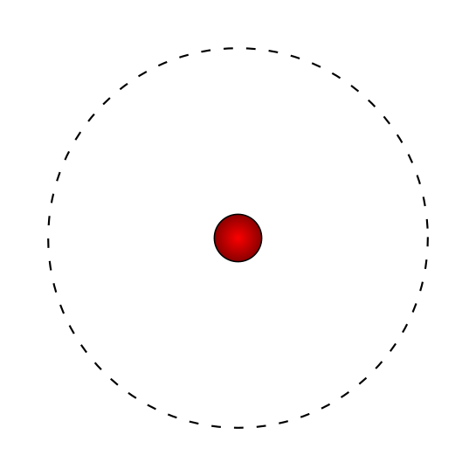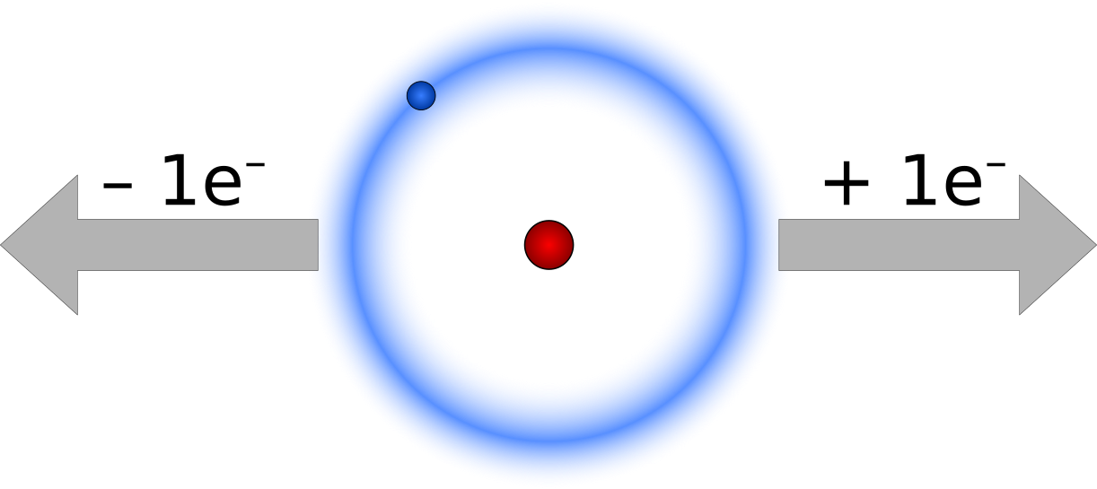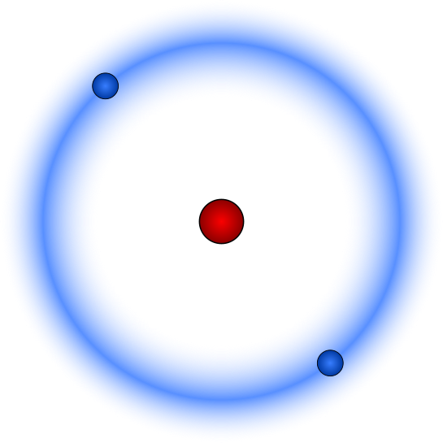
proton (H⁺) hydrogen atom (H) hydride (H–)
For example, hydrogen can either lose or gain an electron. If it gains one, we end up with an anion called “hydride”. If instead H loses an electron, we end up simply with a proton, so chemists normally call this the “proton ion” H⁺, or just a “proton”. This can be a little confusing because of p⁺; so “carbon has six protons” means six p⁺ in its nucleus, not six H⁺ ions.

Question
Draw, including the electrons, the lithium atom and the lithium ion, ₃Li⁺.
Activity Title: | 02-07.Neutrons determine the isotope |  |  | v03
Learning Target: |  | To identify that isotopes are types of the same element
Authors/References: |  |  | Victor Sojo

We’ve seen what happens when we change the number of protons (a different atom) and electrons (an ion). How about neutrons?

Changing the number of neutrons does not change the element, but it makes varieties of it called isotopes.

Neutrons and protons are sometimes called nucleons (can you guess why?). They have roughly the same mass, which is much larger than that of the electron. For this reason, and to distinguish between isotopes of the same element, the number of nucleons is sometimes written in the top-left corner of the element’s symbol.
Hydrogen has three isotopes: protium ¹H, deuterium ²H, and tritium ³H. The first one has no neutrons, the second has one, and the third has two:
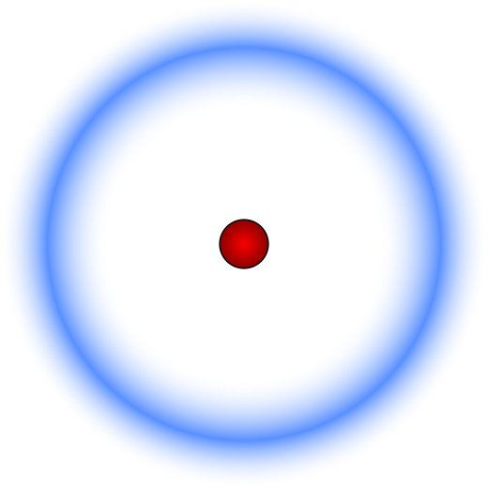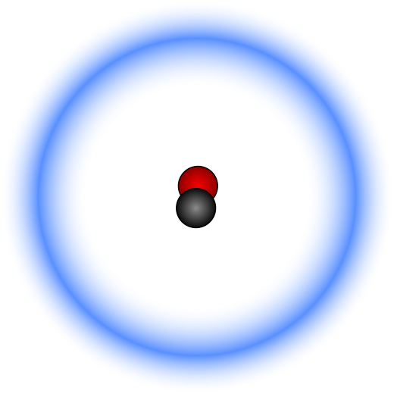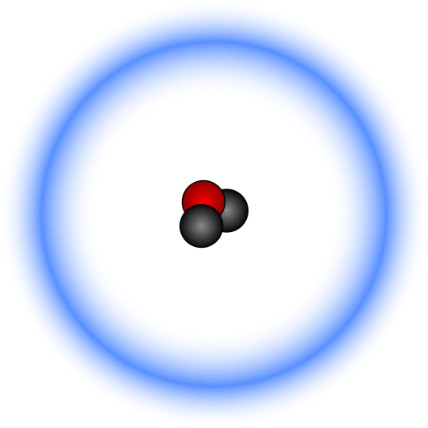
protium (¹H) deuterium (²H) tritium(³H)

Exercise
Carbon also has three natural isotopes, called simply carbon-12 (¹²C), carbon-13 (¹³C), and carbon-14 (¹⁴C). The most common is ¹²C, but everything with carbon (including us!) normally has a bit of the other two.
Choose one of the three carbon isotopes and draw its nucleus.
Activity Title: | 02-08.Elements can combine into compounds |  |  | v02
Learning Target: |  | To identify that compounds such as water are made of two or more elements
Authors/References: |  |  | Victor Sojo

Elements can combine into compounds. One of the most familiar compounds is water, which is made of hydrogen and oxygen. Through experimentation, we can show that there is twice as much hydrogen as there is oxygen. For this reason, we write the chemical formula of water:
H₂O
The little number in the middle belongs to the hydrogen, not to the oxygen. It means that there are two atoms of hydrogen for each atom of oxygen in a water molecule (oxygen has a 1, but we don’t write this). If we could see it, a water molecule would actually look something like this:
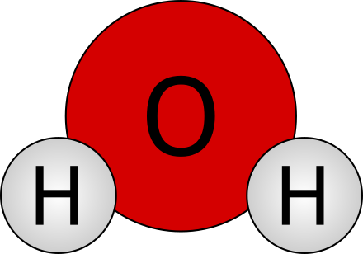 … or drawn another way: 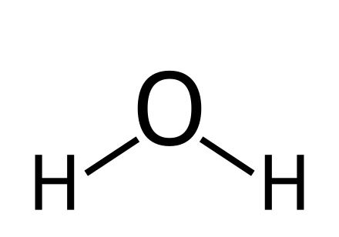
So sometimes chemists write HOH, although H₂O is more common.
But not all compounds form molecules such as HOH. Some compounds, like table salt (NaCl), make a crystal that spreads in all six directions: up, down, left, right, back and forth, without any clear beginning or end. Every sodium ion (Na⁺) is followed by a chloride ion (Cl–), which is followed by another sodium, then another chloride, and so on, in every direction. We write NaCl simply because for every atom of sodium there is one of chlorine.
Exercise: Calculate the numbers of atoms of each element in aluminium sulphate Al₂(SO₄)₃ (note: the 3 multiplies the group in the parentheses).
Activity Title: | 02-09.The four corners of an atomic symbol |  |  | v03
Learning Target: |  | To identify the numbers in each corner of atomic symbols
Authors/References: |  |  | Victor Sojo

The mass number  Same as the number of nucleons (protons + neutrons). It determines the isotope, so we only need to write it if we are considering a specific isotope.  If we don’t write anything, we mean the element just as it is found in Nature.  For oxygen, this would be:  99.76% ¹⁶O  0.04% ¹⁷O  0.20% ¹⁸O |  | The charge  This corresponds to the difference between the total number of protons and the total number of electrons.  If we write nothing, it means the charge is zero.  Otherwise we must always write it. Some people write charges as –2 or +3 instead of 2– and 3+, but the latter are strongly preferred!  When there is only one charge, we just write + or –, without 1.
16 | O | 2–
8 |  | 2
The atomic number Z  Same as the number of protons in the nucleus. It is not necessary to write it because oxygen always has 8 protons, so just by writing the symbol “O” we already indicated that Z=8.  However, sometimes we write Z just to make some discussions easier. |  | The atom count  This indicates how many atoms of this element are present in this particular substance.  If we write nothing, it means there is only one atom.  Otherwise, we must always write the appropriate number.  For example, in H₂O there are two hydrogens and one oxygen.

Question
Write the four numbers at the corners of the ion azide, which has three nitrogen atoms and one negative charge. Assume that each of the nitrogen atoms has 7 neutrons.

Activity Title: | 03-01.Dalton’s atomic theory (~1805) |  |  | v05
Learning Target: |  | To describe the atomic theory of John Dalton
Authors/References: |  |  | Victor Sojo / Brown’s Central Science; Wikipedia

Unlike most scientists of his time, John Dalton (1766-1844) was born poor. He worked and studied very hard and went on to make multiple significant contributions to Science. Chief of these is his Atomic Theory, built upon work by many other scientists of his time (all great Science is built upon the knowledge gathered by previous scientists; this is why we must study their work).

The main ideas of Dalton's atomic theory are:
- Elements are made of extremely small particles (the atoms).
- Atoms of the same element are identical.
- Atoms of different elements are different.
- Atoms are indivisible.
- In a chemical compound, atoms of different elements are combined in simple proportions of integer (whole) numbers (1, 2, 3, …).
- In chemical reactions, atoms are combined, separated or rearranged.
- Atoms cannot be created or destroyed.
- Atoms of an element do not change into atoms of another element.

Questions
- We now know that idea #4 above is wrong. How do we know this?
- We also know that ideas #7 and #8 are right in the vast majority of the chemistry that we do. However, there are cases in which atoms can indeed be created, destroyed, or transformed into other atoms. Do you know which kind of processes these cases belong to?
Activity Title: | 03-02.Thomson’s (1897) and Rutherford’s (1910) models |  |  | v03
Learning Target: |  | To describe the atom models of Thomson and Rutherford
Authors/References: |  |  | Victor Sojo / Brown’s Central Science; Wikipedia

Dalton thought that atoms were indivisible. However, when J.J. Thomson took a glass tube, pumped almost all the air out, and then connected each end of a very strong battery to the two ends of the tube, negative particles flew from the negative end of the battery (the “cathode”) to the positive end (the “anode”). This made Thomson realize that atoms of all elements have negative particles that are easy to move. We now call these particles “electrons”.
But no matter what Thomson did, he couldn’t get any positive particles to move, so he thought that the positive part of the atom must be static (he knew there had to be a positive part because atoms are electrically neutral).
He therefore imagined that atoms must be made of a big solid positive mass, with negative bits (electrons) embedded within, just like chocolate chips in a cookie. That’s why we call this the “plum-pudding” model. It was very advanced for its time, but it’s not entirely right. | 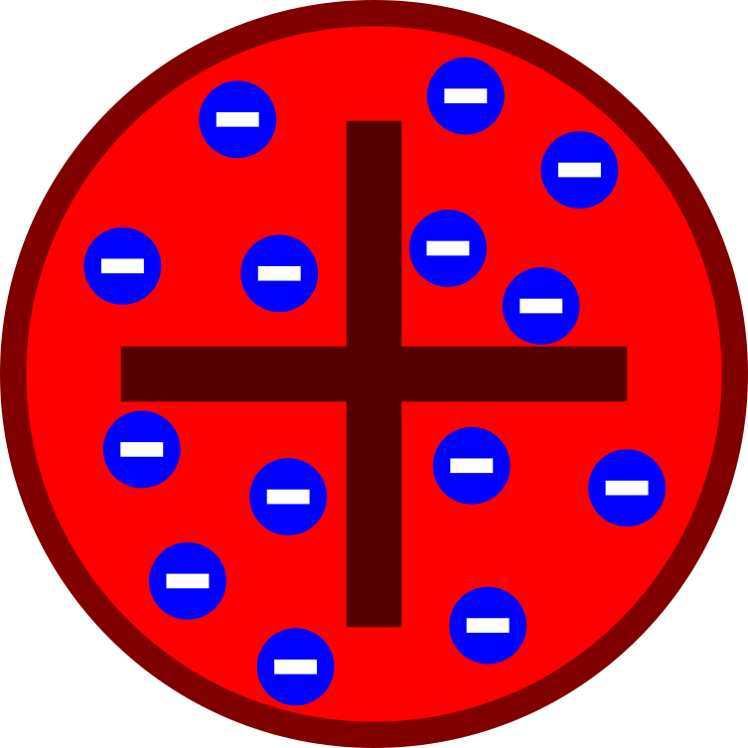
Trying to demonstrate that his mentor Thomson was right, Ernest Rutherford shot small “alpha” particles against a very thin sheet of gold. He was expecting most particles to bounce back after smashing against the solid wall of plum-pudding atoms but, to his surprise, most went through! Only a few did bounce back. He concluded that the atom must be mostly empty (that’s why most particles went through), with a positive nucleus and the electrons around it like planets to the sun.
Exercise: Draw Rutherford’s planetary model of a Lithium atom (3 electrons). Note that in 1910 Rutherford knew nothing of protons, neutrons or orbitals. These were discovered later.
Activity Title: | 03-03.The modern, quantum-mechanics view of the atom |  |  | v04
Learning Target: |  | To describe the modern understanding of electronic structure based on Quantum Mechanics
Authors/References: |  |  | Victor Sojo / Brown’s Central Science; Wikipedia

Thomson (1897) discovered that atoms have easy-to-move electrons. Then in 1910 Rutherford discovered the nucleus, and suggested a planetary model. In 1919, Rutherford himself discovered protons, positive particles that compose the nucleus, and Chadwick discovered neutrons in 1932.
This painted a full picture of the atomic particles (neutrons and protons in the nucleus, electrons distributed away around the nucleus). But how exactly are electrons distributed around the nucleus?
Many discoveries, hypotheses, discussions and even quarrels have led to our current understanding, based on a theory called quantum mechanics. The main contributors have been scientists such as Planck, Einstein, de Broglie, Heisenberg, Schrödinger, Pauli, Hund, and many others.
The theory is very complex, and we cannot go over it in detail here, but we can study some important conclusions of what we know:
- Electrons behave both as particles (like a ball) and waves (like sound).
- Electrons are not in simple 2-dimensional planetary orbits, but instead in 3-dimensional “orbitals”.
- Orbitals are not like bags in which electrons are held, but instead they are volumes where it is most likely (or probable) to find an electron.
- There cannot be more than 2 electrons in any orbital.
- Atoms have four main types of orbitals: s, p, d, and f (always lowercase).
- s orbitals only take 2 electrons. p orbitals are actually three separate orbitals, so they take 6 electrons in total. d orbitals are actually five separate orbitals, and f orbitals are actually seven.
Question: How many electrons fit into the d and f groups of orbitals?
Activity Title: | 03-04.Electronic configurations and the rain method |  |  | v03
Learning Target: |  | To describe our current view of electronic structure
Authors/References: |  |  | Victor Sojo / Brown’s Central Science; Wikipedia
Electrons tend to occupy the orbital with the lowest energy available.
In most cases, the energy of orbitals increases, from left to right:
1s 2s 2p 3s 3p 4s 3d 4p 5s 4d 5p 6s 4f 5d 6p 7s 5f 6d 7p
However, remembering this seemingly disordered pattern is a little difficult, so many chemists like to use a mnemotechnic tool called the rain method:
We respectively add the first s p d and f orbitals at every major step (1, 2, 3, and 4), starting with 1s, then 2s 2p, then 3s 3p 3d, and then 4s 4p 4d 4f, and from 4 onwards we just add all four. We then draw diagonal arrows from the top-right, through the orbital names. To get the electron configuration of an atom or ion, we follow the first arrow, then the second, and so on. | 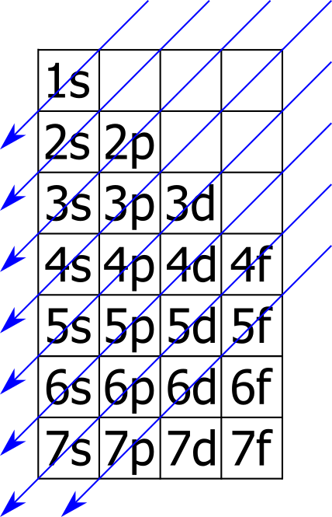
So, for the rubidium ion ₃₇Rb⁺, which has 36 electrons, we have:
₃₇Rb⁺: 1s² 2s² 2p⁶ 3s² 3p⁶ 4s² 3d¹⁰ 4p⁶
Note that d¹⁰ actually means that there are 2 electrons in each of the five d sub-orbitals. There cannot be more than 2 electrons in any orbital (this is called Pauli’s exclusion principle). In total, there can be a maximum 2 electrons in each of the s orbitals, 6 in the p, 10 in the d, and 14 in the f.
Question: Look at a periodic table and count how many columns (“groups”) there are in each of the four blocks marked. Write the number in the figure. Do you notice anything? | 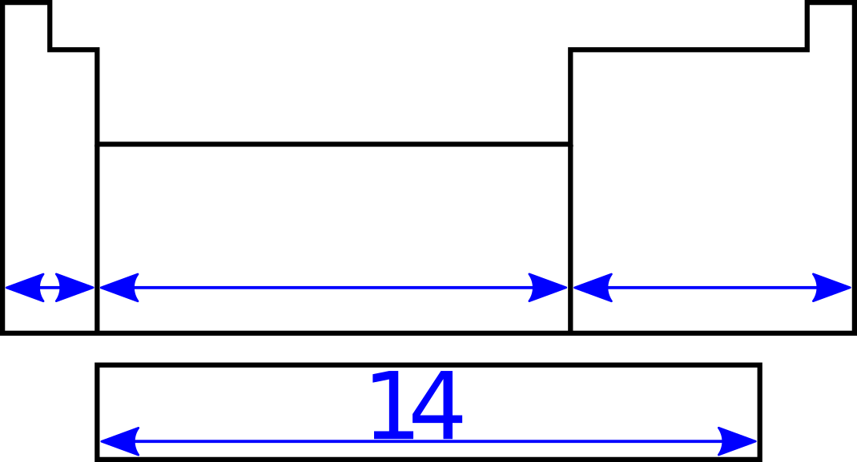
Exercise: Determine the electronic configurations of the following atoms or ions: ₁₇Cl–, Mg²⁺, Kr, ₈₆Rn⁰.
Activity Title: | 03-05.Regions of the periodic table |  |  | v02
Learning Target: |  | To detect the regions of the periodic table
Authors/References: |  |  | Victor Sojo / Brown, Chemistry 14ed.
The elements in the periodic table can be grouped in many ways. The simplest of these is just in vertical groups, from 1 to 18. Since the elements within a group tend to have similar properties. Some of these groups have been given names, in particular groups 1, 2, 17 and 18:
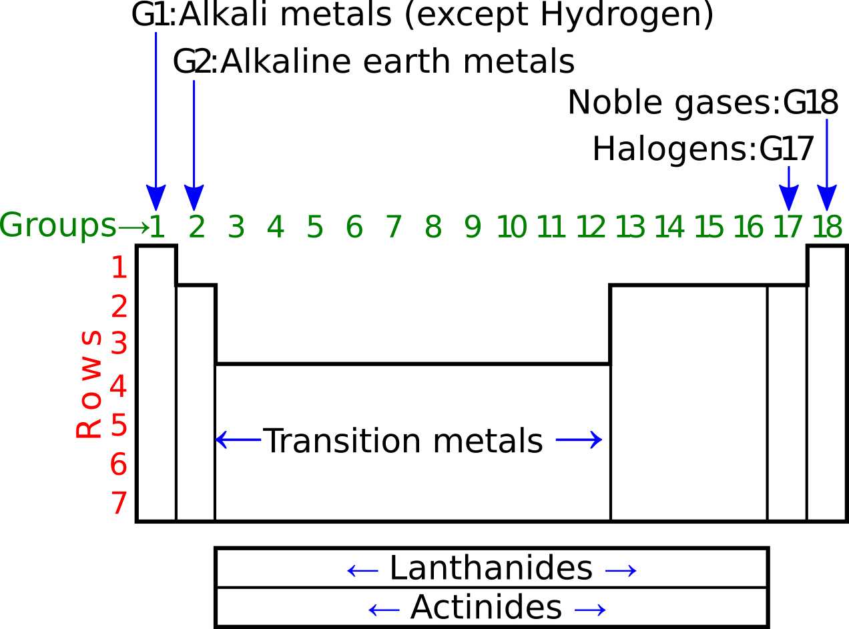
There are some groups that are clumped together, such as the transition metals (groups in the d block) and the lanthanides and actinides (groups in the two rows of the f block). This is because they share similar properties.
We can also cluster elements in terms of how metallic they are. Metals have similar properties; for example, they tend to conduct electricity and heat very well, and they are easy to bend and shape (ductility and malleability). Most pure non-metals don’t conduct electricity or heat very well.
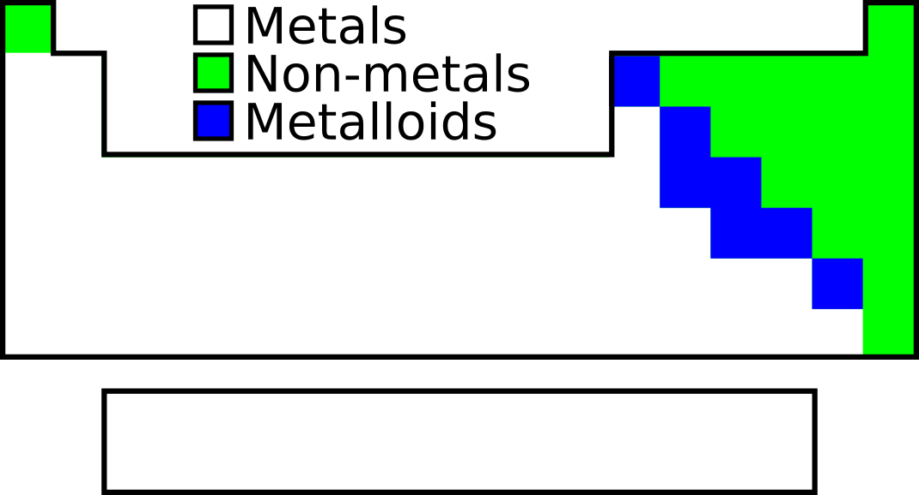
Question: Can you guess the electrical properties of metalloids like silicon?

Activity Title: | 04-01.Elements as atoms, molecules, and lattices |  |  | v02
Learning Target: |  | To identify that pure elements exist in different structures
Authors/References: |  |  | Victor Sojo / Wikipedia: Element; Brown, Chemistry 14ed.

Some elements are typically found in the Universe just as single atoms that float around on their own and don’t interact much with any other atoms. This is the case of the noble gases such as Neon and Argon, both of which are present in very small concentrations in the air we breathe:
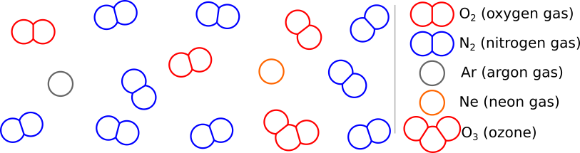
There are many more molecules of nitrogen (N₂) in the air, formed by two atoms of the element nitrogen. There is also plenty of oxygen (O₂), formed by two atoms of oxygen. O₂ is the most common form of the pure element oxygen on Earth. However, you will notice that there is also a little bit of ozone (O₃). Up in the stratosphere (about 20 to 30 km upwards), there’s a little more ozone than down on the ground.
All molecules are formed by two or more atoms. These atoms don’t have to be of the same element. For example, carbon dioxide (CO₂) and water (H₂O) are both molecules also present in the air in small amounts.
Some elements don’t form molecules, but they are also not alone as atoms. This is the case of metals such as gold, silver or aluminium, which form a lattice, a kind of three-dimensional pattern. | 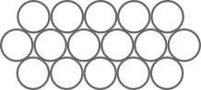
Question: Try to draw the H₂O and CO₂ molecules (hint: C is in the middle of the CO₂ molecule). We will see their exact shapes later.
Activity Title: | 04-02.Ionic, covalent, and metallic bonds |  |  | v03
Learning Target: |  | To identify the different types of chemical bonds
Authors/References: |  |  | Victor Sojo / Wikipedia: Bond; Brown, Chemistry 14ed.

There are three main types of bonds in chemical substances: ionic, covalent, and metallic.
Ionic bonds: Saltwater contains many Sodium cations Na⁺ and chloride anions Cl–. If we fill a pot with seawater and evaporate all the water, the ions
Na⁺ and Cl– can no longer float around in the water. Instead, they now move towards each other because of their opposite charges and form a crystal of NaCl “sodium chloride”. This union formed because of the attraction between negative and positive particles (e.g. in salts) is called an ionic bond. | 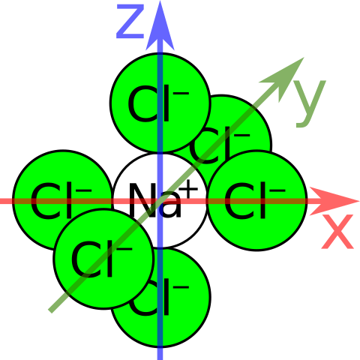
Covalent bonds: Water is a molecule with formula H₂O. Atoms in molecules
are bound to each other by pairs of shared electrons. We call these pairs covalent bonds, and we normally draw them as sticks. Remember: each bond
or stick corresponds to two electrons. Sometimes we draw double sticks, which are simply double bonds, made of two electrons each, four in total.
Metallic bonds: Metals do not form molecules. Instead, they form large
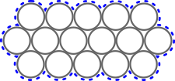  --cloud of shared electrons-- | three-dimensional networks or lattices in which all the atoms share electrons. The metallic bond is caused by the sharing  of these electrons. And the shared-electron
cloud is also why metals are so good at conducting electricity.
Question: What type of bonds do atoms in these compounds form?
a)18K gold in a ring. b)CO₂. c)KF (potassium fluoride) d)Steel in a ship.
Activity Title: | 04-03.Valence electrons, Lewis structures and the  octet rule |  |  | v03
Learning Target: |  | To identify the reacting electrons of an elements
Authors/References: |  |  | Victor Sojo
Elements can have many electrons. For example, neutral silver has 47, and neutral lead has 82. Not all of these are involved in chemical reactions. In fact, only the outer electrons participate in chemical reactions. These are called the valence electrons, underlined as follows:
₁H:1s¹ | ₉F:1s²2s²2p⁵ | ₂₀Ca:1s²2s²2p⁶3s²3p⁶4s² | ₂He:1s² | ₈O:1s²2s²2p⁴
When elements react, they often gain, lose, or share electrons until they end up with a s²p⁶ configuration. This is called a full or “closed” shell.
The noble gases (He, Ne, Ar, Kr, Xe) do not tend to react at all. This is because they already have a closed shell, which is very stable. For this reason, some like to say that atoms tend to get the electronic configuration of the closest noble gas.
Calcium, for example, can lose its two valence electrons and form the ion calcium, Ca²⁺:1s²2s²2p⁶3s²3p⁶, which has the configuration of argon (₁₈Ar).
Fluorine would instead tend to gain one electron and end up as the ion fluoride with the configuration of ₁₀Ne, F–:1s²2s²2p⁶. Unsurprisingly, calcium reacts with fluorine, forming calcium fluoride: Ca + F₂ CaF₂
Here, two electrons were transferred from calcium, one to each fluorine.
But sometimes neither element would benefit from losing electrons, so they share. Hydrogen would welcome one electron and end up with a helium-like 1s²,
whereas oxygen would prefer two and have neon’s 1s²2s²2p⁶. The solution? Two hydrogen atoms can each share one electron with one oxygen atom. | 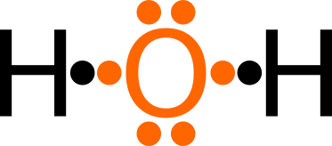  Lewis structure of H₂O
In this Lewis structure, we normally end up with eight electrons around each atom (except H, which ends up with 2). This is called the octet rule.
Exercise: Draw the Lewis structures of H₂, O₂ and CO₂.
Activity Title: | 04-04.Kekulé (stick-bond) structures. |  |  | v01
Learning Target: |  | To draw stick structures common in modern chemistry.
Authors|References: |  |  | Victor Sojo | Wikipedia: August Kekulé; Covalent bond

Lewis structures represent each electron as a dot. Let’s draw the Lewis structure for ammonia (NH₃). First, we need the electronic configurations:
₁H:1s¹ ₁₄N:1s² 2s² 2p³ (valence electrons underlined)
Now we can draw the Lewis dot structure, assuming N is in the center:
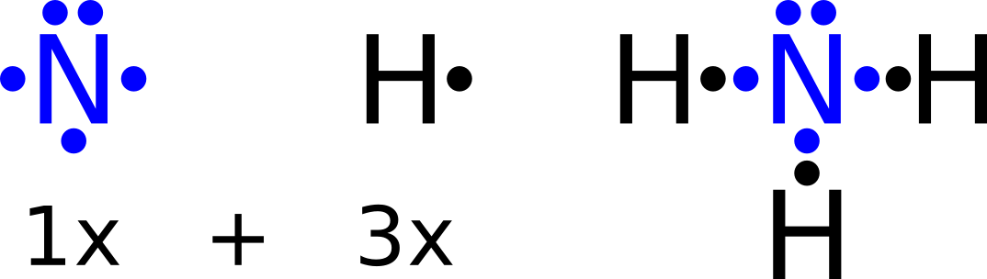
Another way of presenting electrons is drawing each pair as a stick. This is called a Kekulé structure:
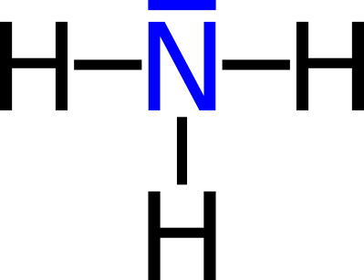
Neither pure Lewis-dot nor pure Kekulé-stick structures are common in modern chemistry. Instead, chemists most often use a hybrid model in which we present bonds as Kekulé sticks, but unpaired electrons (those electrons that are not in a bond) as Lewis dots:
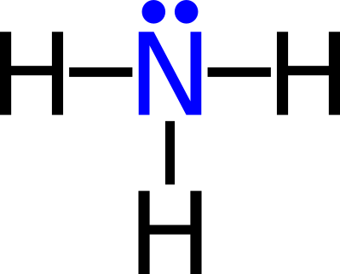
Actually, the unpaired electrons are optional, and chemists often do not draw them (but often they do, when they think it is important to do so).
Exercise: draw the pure Lewis, pure Kekulé, and modern structure with unpaired electrons for hydrogen fluoride (HF) and molecular nitrogen N₂.
Activity Title: | 04-05.Electronegativity and polarized covalent bonds. |  |  | v01
Learning Target: |  | To realize why water has permanent electric poles.  To draw the angled (non-linear) shape of water.
Authors|References: |  |  | Victor Sojo | Wikipedia: Covalent bond.

We know that atoms in a covalent bond share a pair of electrons:
Here, the two electrons are in an evenly distributed electron cloud. However, in many cases the sharing of electrons is not perfectly even. For example, in the case of the H–O bond, oxygen attracts electrons more than hydrogen does (oxygen is more “electronegative”). The electrons in the H–O bond are therefor displaced towards the oxygen atom, and the electron cloud is not even. This creates a slightly positive (δ⁺) charge density on the hydrogen atom, and a slightly negative density (δ–) on the oxygen:
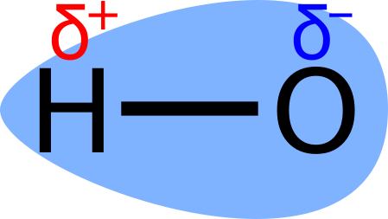
This uneven electron cloud is unthe bond polar (it has a positive pole and a negative pole).

Activity Title: | 05-01.Chemical nomenclature |  |  | v03
Learning Target: |  | To assign names to chemical compounds
Authors/References: |  |  | Victor Sojo / Wikipedia:Metal; Brown, Chemistry 14ed.

Humans have been naming substances for a very long time, such as “water”, “vinegar”, “salt”, or “alcohol”. However, we now know that all compounds are made from the same 118 elements, so chemists have been able to develop systematic (organized) ways of naming compounds. This is called chemical nomenclature.
Let’s first learn some major types of compounds in inorganic chemistry:
Salts are typically made of a metal cation and a non-metal anion. We’re already familiar with common table salt, sodium chloride (NaCl); but there are many more binary salts (made of only two elements), such as barium chloride (BaCl₂), potassium fluoride (KF), aluminium sulfide (Al₂S₃), and lithium nitride (Li₃N).
Ternary salts are made of three elements. Typically, oxygen is part of the anion, in which case it is called an oxyanion. They include sulfates (SO₄^{2–}), phosphates (PO₄^{3–}), nitrates (NO₃–), carbonates (CO₃^{2–}) and many more.
Hydroxides are a special kind of ternary salt, in which the anion is always OH–. They include common bases (or alkalis) such as NaOH and Ca(OH)₂.
Metal oxides are also ionic (like salts). A most familiar one is ferric oxide, Fe₂O₃, also called iron(III) oxide (because the charge of iron is 3+). There is also the iron(II) or “ferrous” ion, Fe²⁺, which forms ferrous oxide FeO.
Non-metal oxides have covalent bonds, such as in carbon dioxide, CO₂.
Acids have hydrogen as the proton ion, H⁺, and one of the anions from the binary or ternary salts. Some well-known ones are hydrochloric acid (HCl), sulfuric acid (H₂SO₄), nitric acid (HNO₃), and phosphoric acid.
Exercises: We didn’t really give any full examples of ternary salts above. Write the formulas for sodium sulfate, barium nitrate, and calcium phosphate. For this, you need the charges of the cations: Na⁺, Ba²⁺, Ca²⁺.
We also didn’t give the formula for phosphoric acid. Can you deduce it?
Activity Title: | 05-02.Common cations and anions |  |  | v03
Learning Target: |  | To familiarize with the most typical inorganic ions
Authors/References: |  |  | Victor Sojo, Jerome Sadudaquil / Chang, Chemistry 10th ed., pp. 60–61; Petrucci, Chemistry 10th ed., pp. 88-91
CATIONS WITH A UNIQUE CHARGE simply receive the name of their element, such as the silver ion, Ag⁺. Here are the most significant ones:
Only 1+: All in Group 1 of the periodic table (Li⁺, Na⁺, K⁺, Rb⁺, Cs⁺), Ag⁺.
Only 2+: All in Group 2 (Be²⁺, Mg²⁺, Ca²⁺, Sr²⁺, Ba²⁺), Cd²⁺, Zn²⁺.
Only 3+: Al³⁺.
CATIONS WITH TWO TYPICAL CHARGES
Here are some useful pairs to remember:
Cu⁺ | copper(I) | cuprous | Au⁺ | gold(I) | aurous
Cu²⁺ | copper(II) | cupric | Au³⁺ | gold(III) | auric
Hg₂²⁺ | mercury(I) | mercurous | Fe²⁺ | iron(II) | ferrous
Hg²⁺ | mercury(II) | mercuric | Fe³⁺ | iron(III) | ferric
Sn²⁺ | tin(II) | stannous | Co²⁺ | cobalt(II) | cobaltous
Sn⁴⁺ | tin(IV) | stannic | Co³⁺ | cobalt(III) | cobaltic
Pb²⁺ | lead(II) | plumbous | Cr²⁺ | chromium(II) | chromous
Pb⁴⁺ | lead(IV) | plumbic | Cr³⁺ | chromium(III) | chromic
ANIONS are not as easy to classify, so let’s just group them loosely:
F– | fluoride | OH⁻ | hydroxide | N³⁻ | nitride
Cl– | chloride | O²⁻ | oxide | NO₂⁻ | nitrite
Br– | bromide | O₂²⁻ | peroxide | NO₃⁻ | nitrate
I– | iodide | S²⁻ | sulfide | MnO₄⁻ | permanganate
ClO– | hypochlorite | SO₃²⁻ | sulfite | CrO₄²⁻ | chromate
ClO₂– | chlorite | SO₄²⁻ | sulfate | Cr₂O₇²⁻ | dichromate
ClO₃– | chlorate | HSO₃⁻ | bisulfite | CO₃^{2–} | carbonate
ClO₄– | perchlorate | HSO₄⁻ | bisulfate | HCO₃⁻ | bicarbonate
PO₄³⁻ | phosphate | HPO₄²⁻ | hydrogen phosphate | H₂PO₄⁻ | dihydrogen phosphate
SOME STRANGE IONS
Hydrogen can be either a cation (H⁺, proton) or an anion (H–, hydride).
NH₄⁺, ammonium, is the only cation discussed here that is not a metal.
We saw the peroxide O₂^{2–} and mercurous Hg₂²⁺ ions above. Do not “simplify” them to O– and Hg⁺! This is incorrect! They must stay as pairs.
Exercise: can you predict the formula of the ion iodate? Hint: Group 17.
Activity Title: | 05-03.Naming compounds |  |  | v02
Learning Target: |  | To practice naming chemical compounds
Authors/References: |  |  | Victor Sojo

Salts are named simply by stating the cation followed by the anion. For example, KI is “potassium iodide”, and Fe₂(SO₄)₃ is “iron(III) sulfate” (or, in the old nomenclature that’s still in use, “ferric sulfate”). To find out how many of each ion we need, we must make sure that the total charge is zero using the smallest possible combination. For Na⁺ and Cl– it’s easy: just one of each. But for Fe³⁺ and SO₄^{2–} it’s trickier. We could have either one Fe³⁺ (3 positive charges), or two Fe³⁺ (6+), or three (9+) or four (12+) and so on. Similarly, we could have one SO₄^{2–} (2–), two (4–), three (6–), four (8–), five (10–), six (12–), seven (14–) and so on. The first time that we have the same number of positive and negative charges is at ±6, so we get Fe₂(SO₄)₃. Technically, 6 is the least common multiple (LCM) of 2 and 3.
Conversely, for lead(IV) sulfate, we have Pb⁴⁺ and SO₄^{2–}, so we only need to get to ±4, the LCM of 2 and 4: Pb(SO₄)₂.
Hydroxides (bases) and metal oxides are named exactly like salts.
Non-metal oxides are much easier to name: we just count the number of each atom and write prefixes that indicate the numbers (mono, di, tri, tetra, penta, hexa, hepta, octa, nona, deca). For example: N₂O₄ is dinitrogen tetraoxide. Note that if the first element has only one atom, we don’t write “mono” for it, but we do for the oxygen: CO is carbon monoxide.
Binary acids are named "hydro{elem-}ic acid”; HCl is hydrochloric acid.
Oxoacids are easier to learn with an example. Sulfuric acid is made from sulfate: H₂SO₄, whereas sulfurous acid is made from sulfite. So just remember that: ____ite ion → ____ous acid, ____ate ion → ____ic acid.
Exercise. Write the name or formula of the following compounds. Salts: KI, CdS, ammonium sulfate, calcium phosphate. Non-metal oxides: N₂O₄, P₄O₁₀, sulfur trioxide. Acids: hydroiodic acid, nitric acid, HNO₂. Bases: Mg(OH)₂.

Activity Title: | 06-01.Stoichiometry - Reactions and equations |  |  | v03
Learning Target: |  | To visualize reactions and start balancing equations
Authors/References: |  |  | Victor Sojo
So far, we have just been naming and describing elements and compounds. But chemistry is the science of changing substances, not static matter. When a substance changes into another, we call this a chemical reaction:
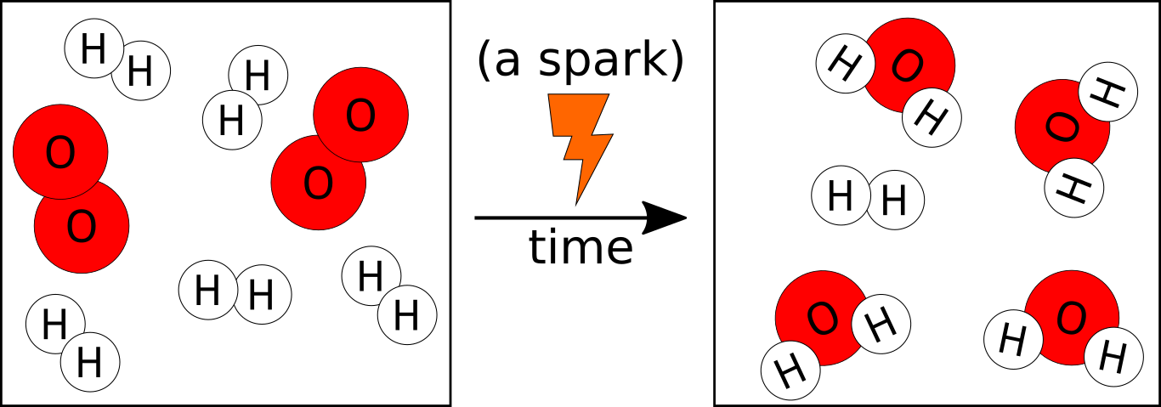
Here, hydrogen and oxygen (the reactants or reagents) reacted, forming water (the product). Count the atoms; you’ll see that the numbers for each element are exactly the same before and after: the atoms only rearrange, their numbers remain the same in chemical reactions (nuclear reactions are an exception, but we won’t study them here). You’ll also notice that some of the H₂ didn’t have any O₂ to react with, so it was left unreacted.
These simple relations have allowed chemists to create very simple mathematical expressions to easily calculate quantities in reactions:
H₂ + O₂ H₂O unbalanced!
Like all good mathematical equalities, these chemical equations must be balanced (what’s on the left-hand side must be equal to what’s on the right-hand side). Let’s count the atoms again. One oxygen seems to have disappeared! That cannot be, so let’s fix it by multiplying water by 2:
H₂ + O₂ 2H₂O unbalanced!
That helped, but now we messed up the hydrogen. It’s easy to fix it:
2H₂ + O₂ 2H₂O balanced
We read this as: “two molecules of hydrogen react with one molecule of oxygen and produce (or yield) two molecules of water”.
Exercise: balance the equation for the formation of Al₂O₃ from Al and O₂.
Activity Title: | 06-02.Balancing equations |  |  | v02
Learning Target: |  | To practice balancing equations
Authors|References: |  |  | Victor Sojo | sky-web: bit.ly/2C1mltt  Wikipedia: Hydrazine; Nitrogen pentoxide.
If a solution to the balancing is not obvious, a good trick is to follow this order: 1)Metals, 2)Nonmetals (except H and O), 3)Hydrogen, and lastly 4)Oxygen. It doesn’t always work, but often it does. Another trick if the previous fails is to leave a pure element (such as Cl₂, O₂, H₂ or F₂) for the end, since multiplying it won’t affect any other element.
Practice makes perfect! Let’s balance a few equations (remember to always make sure that the number of atoms of each element is the same on both sides! Count again after you finish balancing!):
Na + Cl₂ NaCl
Zn + HCl ZnCl₂ + H₂
C₂H₅OH + O₂ CO₂ + H₂O
Al₂(CO₃)₃ + H₃PO₄ AlPO₄ + CO₂ + H₂O
C₆H₁₂O₆ + O₂ CO₂ + H₂O
FeCl₃ + NH₃ + H₂O Fe(OH)₃ + NH₄Cl
NH₃ + H₂O₂ → N₂H₄ + H₂O
S₈ + F₂ SF₆
P₄O₁₀ + HNO₃ H₃PO₄ + N₂O₅
C₄H₁₀ + O₂ CO₂ + H₂O
(H₂N)₂CO + NaOCl + NaOH N₂H₄ + H₂O + NaCl + Na₂CO₃
Activity Title: | 06-03.Moles and Avogadro’s Number |  |  | v03
Learning Target: |  | To define mole as just a name for a number, like “dozen”
Authors|References: |  |  | Victor Sojo | Wikipedia: Mole; Earth; Milky Way
Because atoms are so incredibly small, we need some way to count them easily. Someone had a brilliant idea: just like we defined “a dozen” to mean 12, let’s just define “one mole” (1 mol) to mean a very big, specific number of particles, one that we can weigh easily. But what number to use? Well, since hydrogen is the first element, and we normally weigh things in grams, let’s just make 1 mol be the number of atoms in 1 g of pure ¹H hydrogen. That was a great idea, but hydrogen is volatile and flammable and difficult to purify, so we now define mole as the number of carbon atoms in 12 g of pure ¹²C (without any ¹³C or ¹⁴C). This value, called Avogadro’s number (in honor of Italian chemist Amedeo Avogadro), is approximately 6.02·10²³.
Note that “dozen” just means 12, but it doesn’t specify 12 what (it could be eggs, cakes, hippopotamuses, cars, students, hairpins, dentists… anything!). In the same way, “mole” is just 6.02·10²³, but it doesn’t specify what of. It could be atoms, molecules, ions, cakes, people… anything!
Actually, Avogadro’s number is so large that we could not get so many people, even if every planet in the solar system had people! What’s more, even if every single planet in the whole galaxy had people, we still wouldn’t have 1 mol of students! Let’s prove that. There are close to 8 billion people on Earth. Let’s be generous and round it to 10 billion (10⁹). There are 8 planets in our solar system, so let’s just say approximately 10 planets per star. And there are between 100 and 400 billion (1–to–4·10¹¹) stars in the Milky Way; let’s be very generous again and say it’s 10¹². We have:
$$\frac{{10}^{9} people}{planet}·\frac{10 planets}{star}·\frac{{10}^{12} stars}{galaxy}={10}^{22} people/galaxy$$
So, even if we had as many people on Earth in every single planet of the entire galaxy, we’d still need over 60 galaxies before we had 1 mol people!
Activity Title: | 06-04.Molar masses |  |  | v03
Learning Target: |  | To calculate the mass of 1 mol of any substance
Authors|References: |  |  | Victor Sojo | Wikipedia: Molar mass

So, we know that if we had 1 mol of ¹²C, it would weigh exactly 12 g. But since there’s a bit of ¹³C and ¹⁴C in typical carbon, 1 mol of normal pure carbon actually weighs 12.011 g.
This is called the molar mass of carbon. The standard symbol is M, but we will use that later for “molarity” (the concentration of something dissolved in a liquid), so here we will use the Greek letter µ (“mu”) instead.
Similarly, 1 mol of oxygen weighs 15.999 g, the molar mass of hydrogen is 1.008 g/mol, and that uranium is 238.029 g/mol.
Since we know the formulas of substances, we can easily calculate the molar masses of compounds too. For example, for CO₂:
$µ_{{CO}_{2}}$= $µ_{C}·1$ + $µ_{O}·2$
= 12.011 g/mol + 2·15.999 g/mol
= 44.009 g/mol
Since most molar masses are so close to integers, we often round them (12, 16, and 44 in the calculation above). But some are too far to round up or down; for example, $µ_{Cl}$ = 35.45 g/mol, which shouldn’t really be rounded to either 35 or 36, so we just leave it as is or round only to 35.5 g/mol.
If you’ve heard the term “molecular weight” before, we won’t use it here, firstly because it’s not a weight (it’s a mass), and secondly because it isn’t always a molecule, as in some of the examples below.
Exercise. Calculate the molar masses of: H₂O, NaCl, (NH₄)₂HPO₄, C₂H₅OH.
You may use the rounded numbers here. For example, for H₃PO₃ we have:
$µ_{H_{3}PO_{3}}$=$µ_{H}·3$ + $µ_{P}·1$ + $µ_{O}·4$
= 1 g/mol · 3 + 31 g/mol + 16 g/mol · 3
=

Activity Title: | 06-05.Stoichiometry: reaction with excess of one reagent |  |  | v03
Learning Target: |  | To start calculating amounts of reagents and products
Authors|References: |  |  | Victor Sojo
We can use balanced equations to calculate the amounts of products formed in chemical reactions. For example, let’s calculate the amount of CO₂ and H₂O that would be produced in a full combustion of 6.84 g of sucrose (C₁₂H₂₂O₁₁) with oxygen in the air.
The proportions in a chemical equation do not work for grams, but they do work for particles, so the first thing we must do is find out how much 6.84 g of sucrose is in mol. For that, we need the molar mass of sucrose:
$µ_{C_{12}H_{22}O_{11}}$= $µ_{C}·12+ µ_{H}·22+ µ_{O}·11$ = 342 g/mol
With this, we can calculate the number of mol “n” of butane:
$$n_{sucrose}= 6.84 g sucrose∙\frac{1 mol sucrose}{342 g sucrose}=0.02 mol sucrose$$
Next we need a balanced equation. A full combustion of butane with oxygen in air would produce carbon dioxide and water, so we have in total:
C₁₂H₂₂O₁₁ + 12 O₂ 12 CO₂ + 11 H₂O
And from here we can easily calculate how much of each product was formed. This is easily seen using a table, where we start by filling the first row with the initial (“i”) data that we have, in mol:
C₁₂H₂₂O₁₁ + 12 O₂ 12 CO₂ + 11 H₂O
i) | 0.02 | (in excess) | 0 | 0
We don’t know how much O₂ there was to start with, but the reaction was happening in air, so we know there was a lot of it (it was “in excess”). Of course, there were no products before the reaction, so their initial quantities are both zero. Now we can add two more rows, one for what happened in the reaction “r”, and another one for the final conditions “f”:
C₁₂H₂₂O₁₁ + 12 O₂ 12 CO₂ + 11 H₂O
i) | 0.02 | (in excess) | 0 | 0
r) | –0.02 | –0.24 | +0.24 | +0.22
f) | 0 (nothing) | (still in excess) | 0.24 | 0.22
Question: Can you calculate where the “r” numbers came from?
Activity Title: | 06-06.Limiting reagent and excess reagent |  |  | v03
Learning Target: |  | To determine the limiting reagent. Further calculations.
Authors|References: |  |  | Victor Sojo | Wikipedia: Limiting reagent.
What happens when we know the amounts of both reagents? Normally, we will have too little of one of them, so the other will remain as an excess.
The reaction of tetraphosphorous decaoxide with perchloric acid produces phosphoric acid and dichlorine heptoxide. Let’s say we start with 0.08 mol of P₄O₁₀ and 0.6 mol of HClO₄. We would have, in mol:
P₄O₁₀ + 12 HClO₄ 4 H₃PO₄ + 6 Cl₂O₇
i) | 0.1 | 0.60 | 0.00 | 0.00
r)
f)
To fill in the table, the equation tells us that, for every molecule of P₄O₁₀ that react, 12 molecules of HClO₄ must react with it. If we have 0.10 mol of P₄O₁₀, we would need 12 times that of HClO₄ to react completely, i.e. we would need 1.2 mol HClO₄. We only have 0.6 mol HClO₄, so we know that HClO₄ is the limiting reagent (it limits how long the reaction can go on for), and P₄O₁₀ is an excess reagent. Note that the limiting reagent can actually start out with larger quantities: we had a lot more HClO₄ than P₄O₁₀, but since the relation is 1:12, the HClO₄ ran out much more quickly. The limiting reagent reacts completely, nothing is left of it, so we can fill in our first two missing boxes, the “r” and “f” for HClO₄. Do that now.
We know that HClO₄ reacted completely; now it would be good to know how much of the P₄O₁₀ reacted, and how much is left. That’s easy: the amount of P₄O₁₀ that reacted is 1/12 of the 0.06 mol of HClO₄ that reacted.
Next we have the products. Their quantities are also determined by the limiting reagent. We know that their respective relations to HClO₄ are 12:4 and 12:6. That’s the same as 3:1 and 2:1, or more convenient in this case, 6:2 and 6:3! So, we must have formed 0.2 mol H₃PO₄ and 0.3 mol Cl₂O₇. Note that the stoichiometric relations also remain if you use the “r” numbers for any reagent or product. Exercise: go on and fill in the whole table =)
Activity Title: | 06-07.Calculating reagents from the products |  |  | v04
Learning Target: |  | To determine the necessary amounts of reagents from a desired amount of product in an industrial setting
Authors|References: |  |  | Victor Sojo | Wikipedia: Hydrazine
We now know how to determine the limiting reagent, and calculate the remainder of the excess reagent, as well as the amounts of the products.
But many times chemists want to synthesize something, i.e. they want to make a product, normally in a specific amount. Hydrazine is the main compound in the air bags of cars, and it is also used as a rocket fuel. Let’s say we own a chemical company and want to sell 5 ton (1 ton = 1,000 kg) of hydrazine. We previously balanced this equation:
2 NH₃ + H₂O₂ N₂H₄ + 2 H₂O
i)
r)
f)
We want to know how much ammonia (NH₃) and hydrogen peroxide (H₂O₂) we need to buy to make our 5 ton of hydrazine. For that, we need to find the proportions, but for that we need the molar mass of hydrazine:
$µ_{N_{2}H_{4}}$= $µ_{N}·2+ µ_{H}·4$ = 32 g/mol
With this, we can calculate how many moles of hydrazine we want:
$n_{N_{2}H_{4}}= 5 ton N_{2}H_{4}∙ \frac{1,000 kg N_{2}H_{4}}{1 ton N_{2}H_{4}}∙ \frac{1,000 g N_{2}H_{4}}{1 kg N_{2}H_{4}}∙\frac{1 mol N_{2}H_{4}}{32 g N_{2}H_{4}}=1.56∙{10}^{5} mol N_{2}H_{4}$
We can go ahead and write that into the table above… and the rest is easy! We need just the same amount of hydrogen peroxide (the relation is 1:1) and double the amount of ammonia:
$$n_{NH_{3}}= 1.56∙{10}^{5} mol N_{2}H_{4}∙ \frac{2 mol NH_{3}}{1 mol N_{2}H_{4}}=3.12∙{10}^{5} mol NH_{3}$$
Exercises: We can’t really buy moles from our industrial supplier, so let’s calculate how many tons of each of the two reagents we need.
And just to make our industrial scenario a little more realistic, let’s say the supplier sells us the reagents in 200 kg containers. How many containers of each reagent would we need?

